21 May 2025

Linux Commands

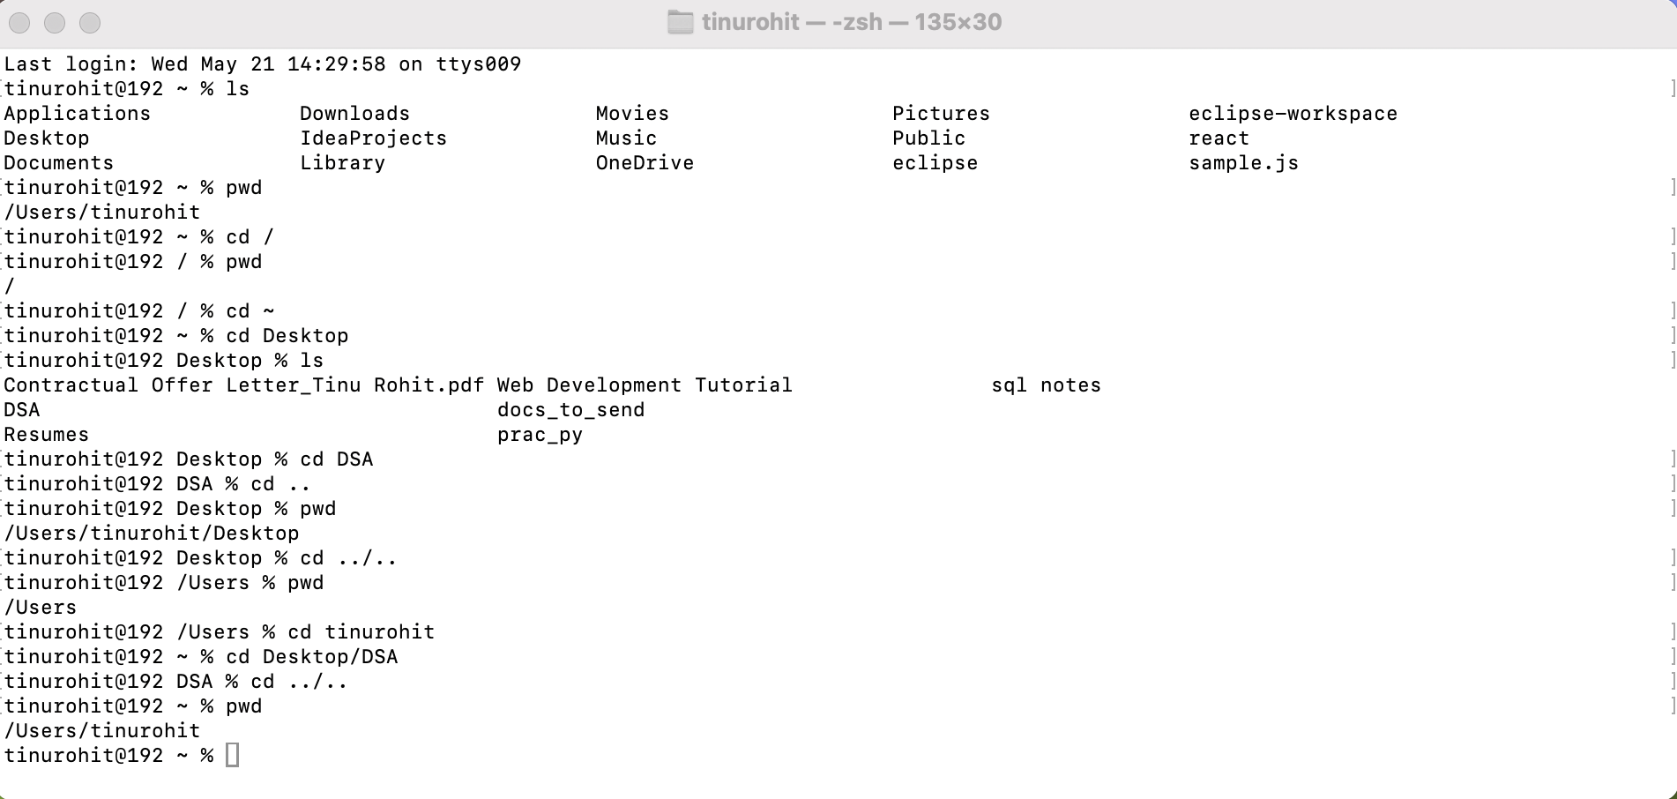

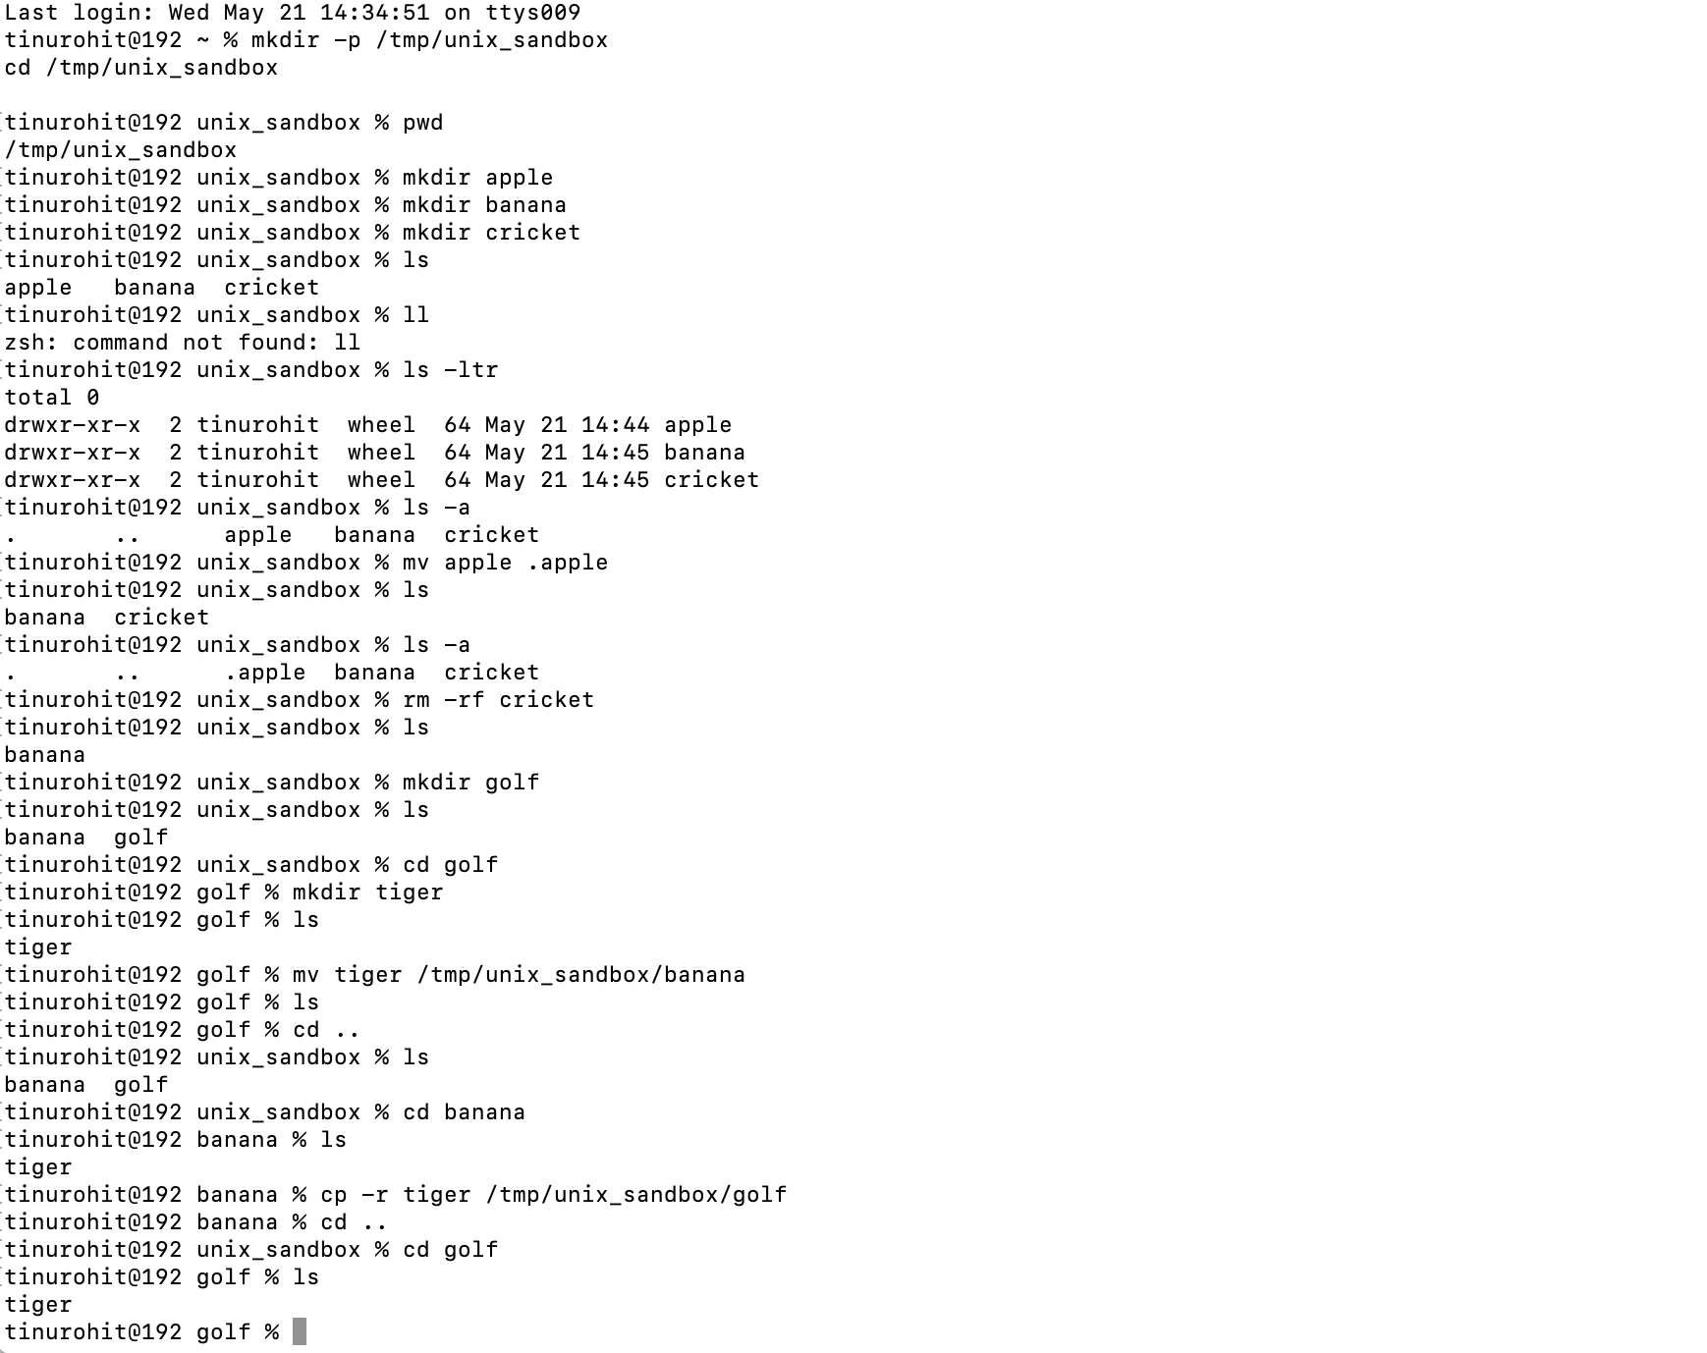

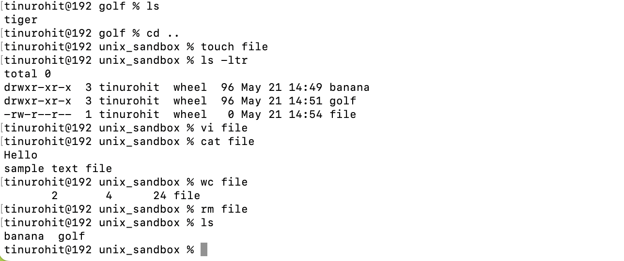

drwxr-xr-x

d at the start of below pic says both are directory

* At the start shows it is file

Change permissions using chmod

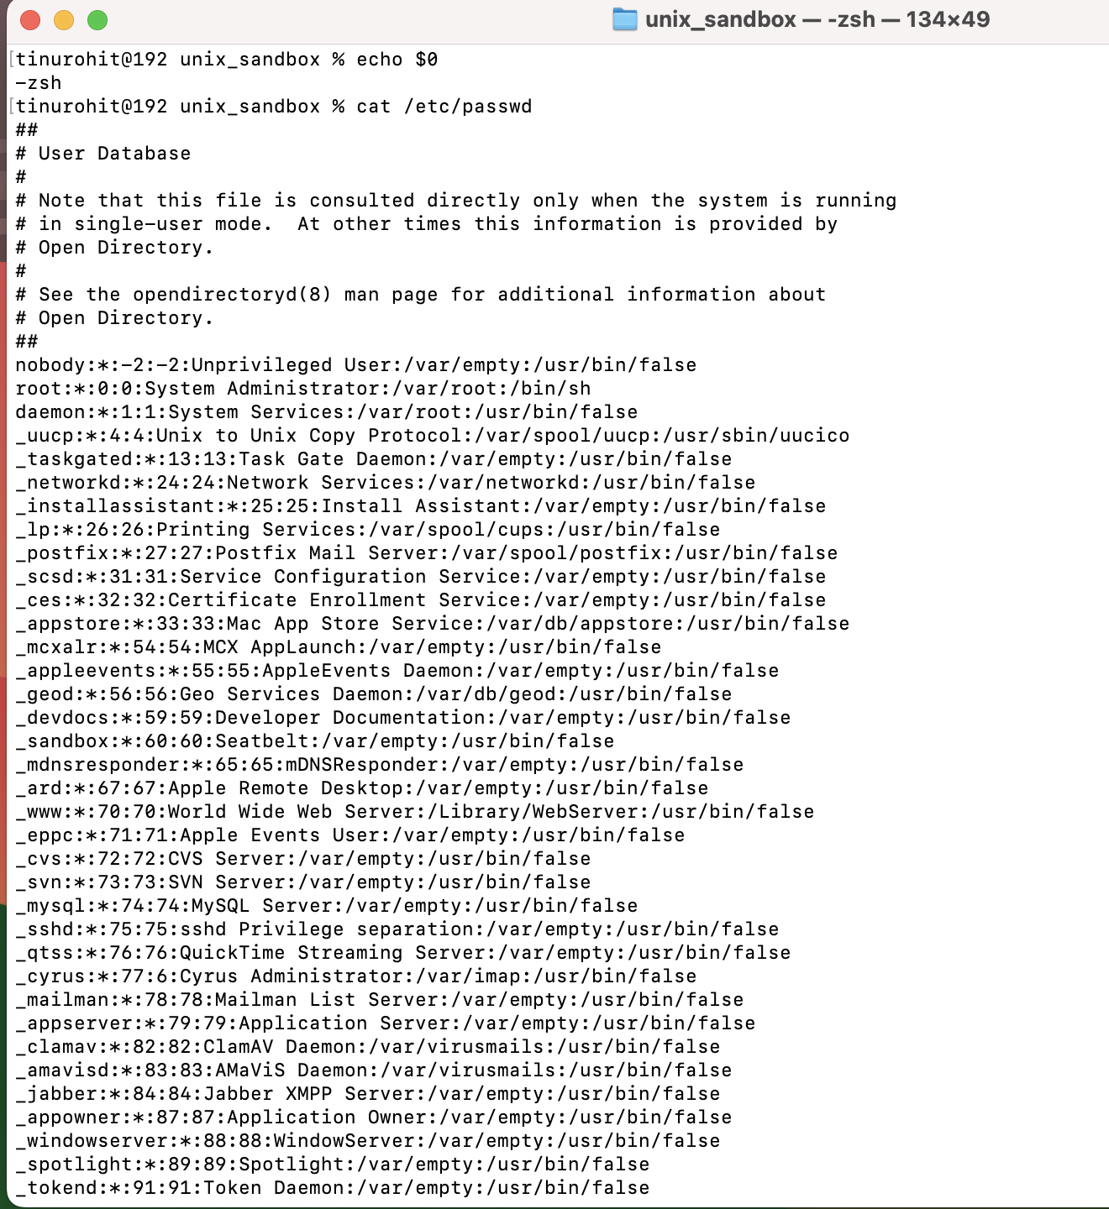

Change ownership

List of available user

Adding a new user named TECH



Creating password for created user

Switch user su

Adding sudo permission to tech

I/O Redirection:

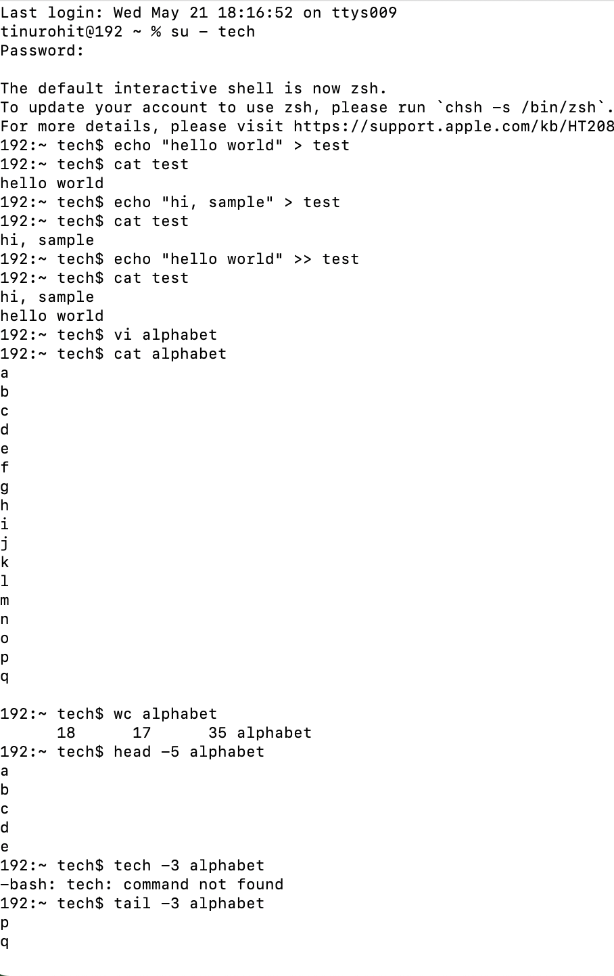

Monitor a file in real time

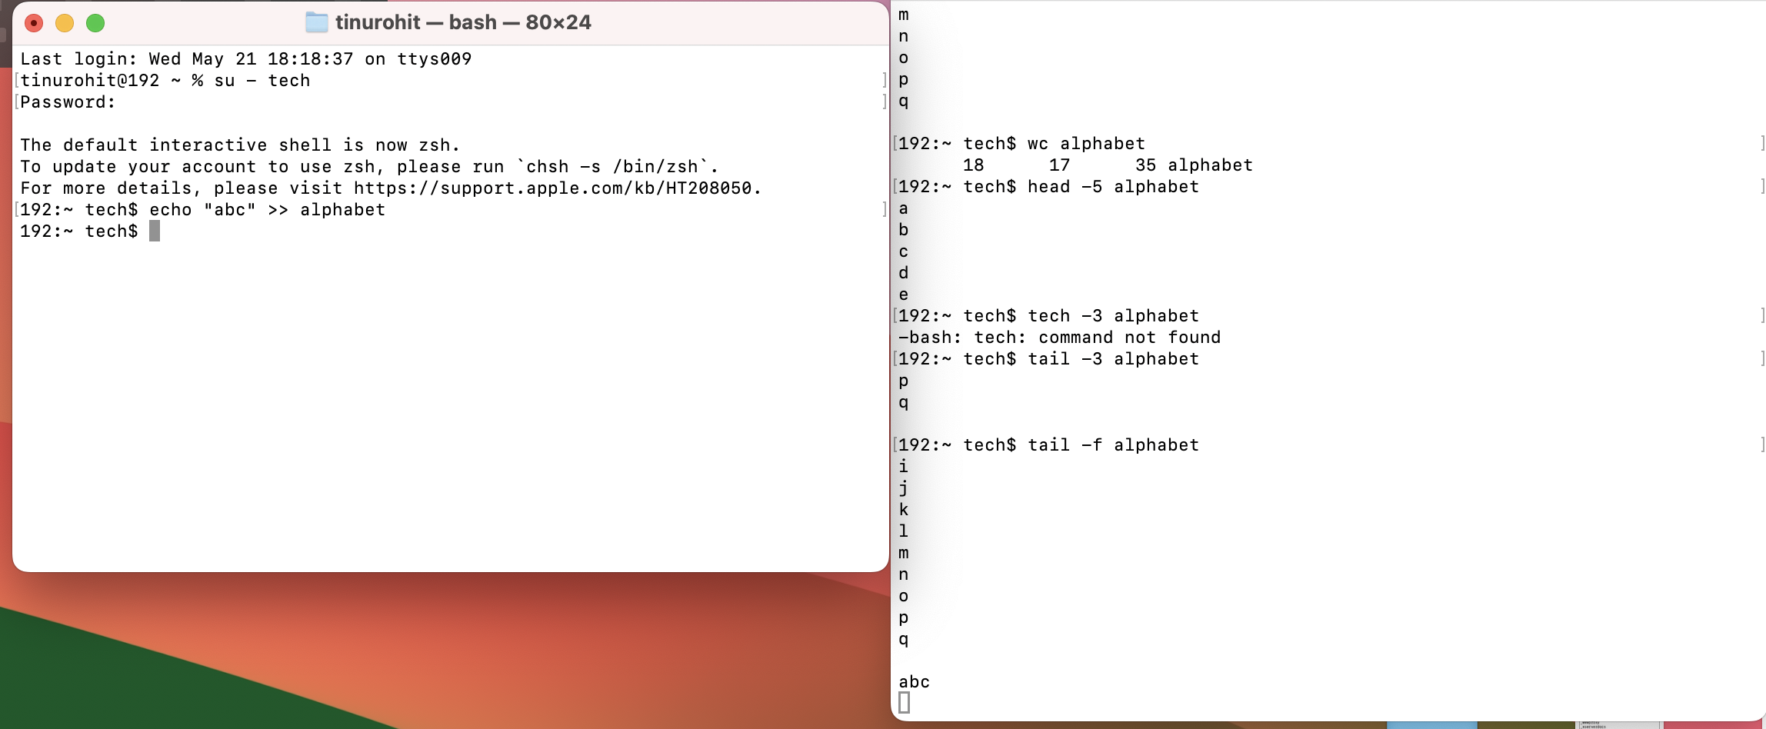

Display all .txt files

Checks files that is older than 30 days

Find is used to find file or directory

Now to find keywords will be using grep

